Abstract
This project is aimed at creating a network-capable Moon buggy game, using our AMC embedded boards. This game will test the NetDIMM boards ability for network gaming. We plan to implement a minimum of three boards. One board will be acting, as a server while the other two will be set as the clients, which are entering to play our moon buggy game. We will also have a web interface that will display the users’ scores.

Table of Contents

Title………………….. page 1
Title………………….. page 1
Title………………….. page 1
Title………………….. page 1
Title………………….. page 1
Title………………….. page 1

Table of Figures

Title………………….. page 1
Title………………….. page 1
Title………………….. page 1
Title………………….. page 1
Title………………….. page 1
Title………………….. page 1

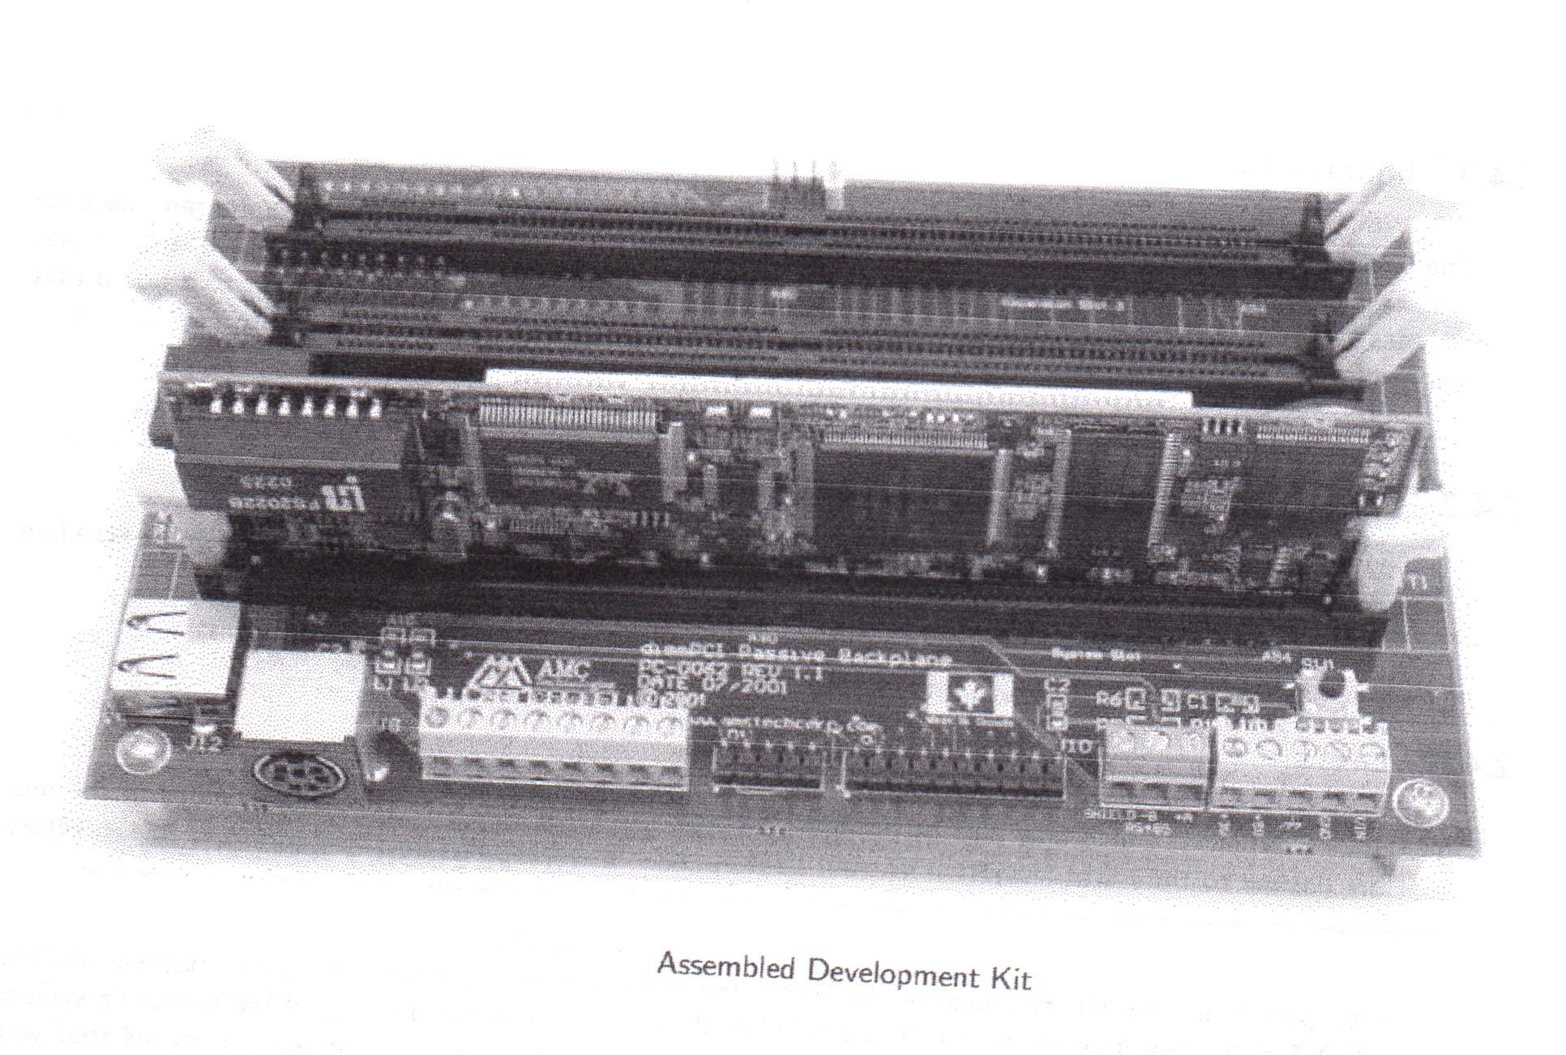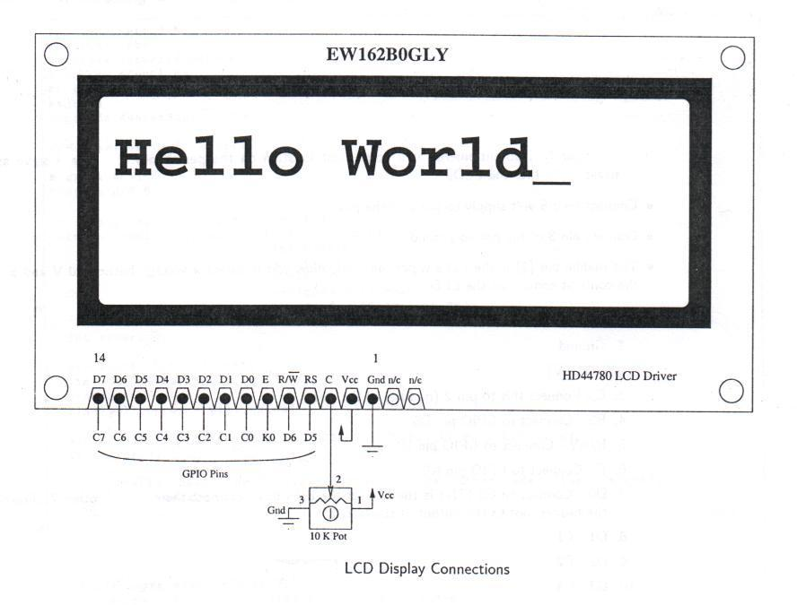

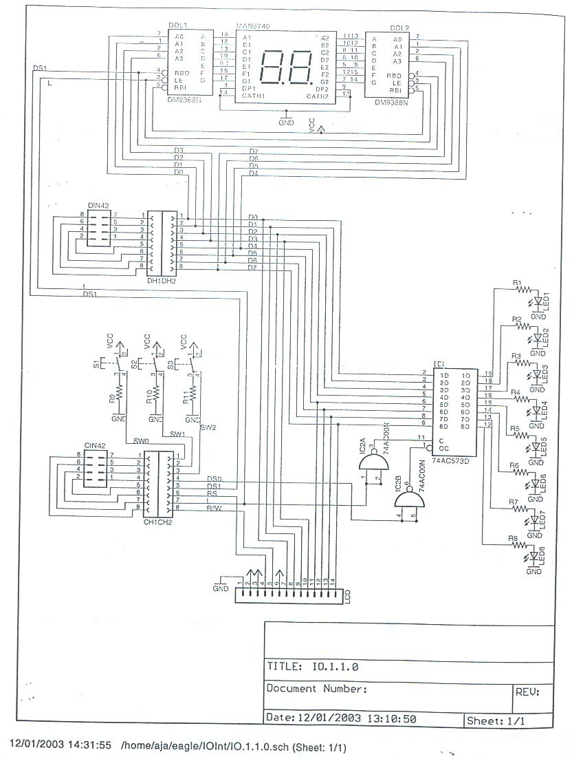
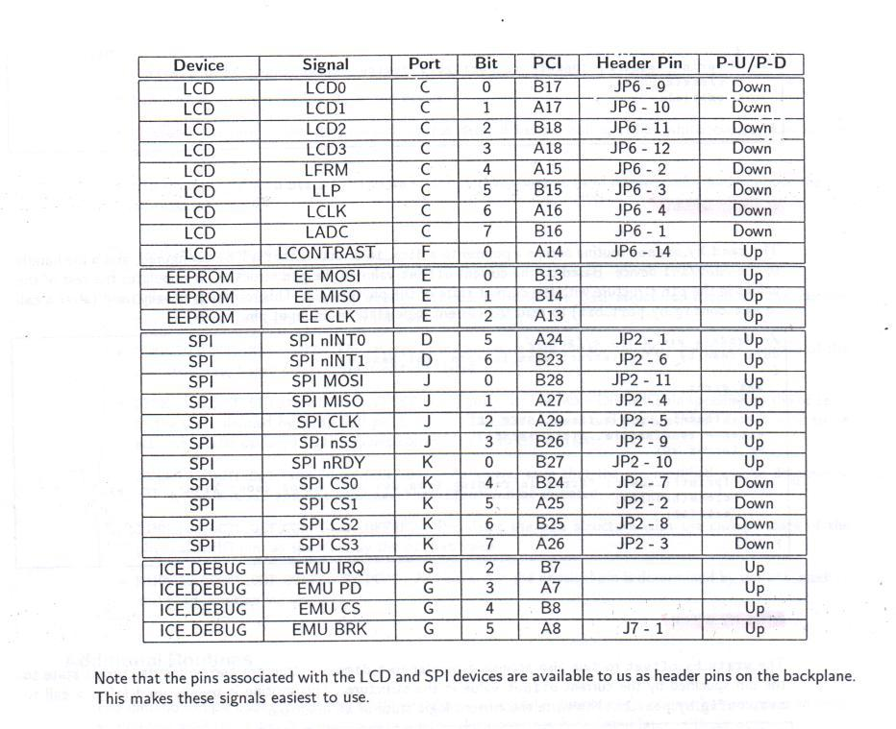

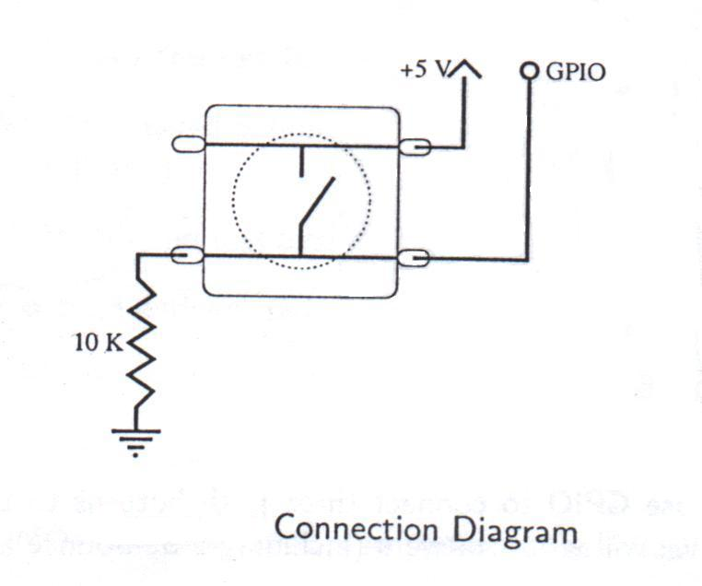

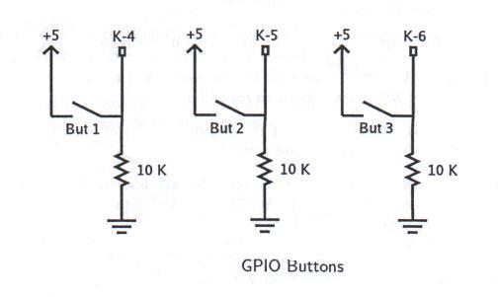

All above pictures were provided by AJ Armstrong.
Overview
The project’s primary purpose is to test the embedded board on its network gaming capabilities. The material used in this project are, the AMC development board and a perforated board we composed containing an LCD and buttons which will be used in our network game.
This game will be entirely written in the C language. We compiled the code for testing purposes on the on a standard Linux machine. After fixing the bugs and putting the code through its initial testing we then compiled the code to work on our development board.
In short, there will be a minimum of 2 players and 1 server. The code can support additional clients, however, the more boards used will slow down game play. The game will be displayed on the LCD screen and the buttons to navigate the moon buggy. After the game is over it will display whether you one or lost, in addition, it will display who the winner of the game is. These results are then recorded and the results of the game will be displayed on a webpage. The webpage will also contain a running total of scores for a particular player.

Background
When designing our project we worked towards testing the network gaming capability. There might not be a huge market for our project because currently game programming is very extensive and require a lot from the hardware aspect. Our goal was not to market our game, it is to show how we can network the boards implementing this technology and our features can easily be changed to design something a client may be interested in.

Constraints
While designing and implementing our design there were some constraints and limitations encountered. The interface of the board is quite limited, it consists of just three buttons and the LCD. The LCD is quite restricting since because of its size, it contains only two lines.
The storage space on the development board is limited, which means graphics we are using for the webpage is limited.

Design

The project consists of two components: a server and a client.

Server

The server has a number of functions. It manages client connections, starts and ends games, stores scores and other player statistics, and generates a web interface containing all player statistics. The server and client communicate using a simple message-based protocol running over UDP.
The server starts by opening a datagram socket, listening (by default) on port 6544. It enters a loop, waiting for JOIN commands. When a JOIN is received, the address of the client is stored, along with the player name supplied with the command. The address will later be compared to those of incoming commands, to determine which client issued them. The client is immediately issued a WLCM command, informing it that it has successfully connected to the server, and will be included in the next game. When the minimum required players have joined, the server issues a REDY command to all the clients. This command informs the clients that the game is expected to begin in the given number of microseconds. The server then continues looping, waiting for more connections, until the timer runs out.
To start the game, the server first uses the system clock to get a number for use as a random seed. This seed will be sent to the clients, and will then be used to generate the landscape the player must navigate. This guarantees that all players will face an equal challenge. The server issues a STRT command, including the random seed, to all the clients. At this point, the game begins!
The server enters a loop, waiting for SCOR or DEAD commands from the clients. If a SCOR is received, the players score will be updated. If a DEAD is received, the player will be marked dead and his or her score will be updated. If a new client attempts to join the game during play, it is issued a WLCM command, and is excluded from the current game. Periodically, the web page is written, containing up-to-date scores and statistics about the players. When the last client has issued a DEAD command, the server determines who has the highest score, and issues an OVER command to all clients, supplying the name and score of the winner.
At this point, the server returns to the JOIN loop, waiting for more players.

Client
The client is the portion the user interacts with. It has two user interfaces, one designed using curses for the Unix console, and one for the NetDIMM interface board. In either case, the available screen space is considered to be 2 lines of 16 characters each. Three keys are used: up for jump, left for faster, and right for slower. The landscape scrolls from left to right across the bottom line of the screen at a rate of 10 characters per second. The buggy occupies one space, on the top line when jumping, on the bottom line otherwise. Every character passed successfully is considered to be worth one point.
The user interface designed for the NetDIMM interface board uses a set of custom characters to represent the ground, craters, boulders, and the buggy itself. The console interface simply makes use of available characters.
The client requires two command-line arguments, the first is the name of the player, the second the hostname of the server to connect to. When the client is launched, it first initializes the screen, and then creates a datagram socket, and attempts to connect to the server by sending a JOIN command.

Results

Appendices

